**4.n Tutorial Design**

**4.n.1 Swap Tutorial page**

In the tutorial section, we developed a module that introduces the basic idea of swapping two elements in a programming context. As a newcomer of programming would have little knowledge about this operation swap, we designed this page to explain how swap operates. This page helps users prepare for understanding sorting algorithms that will use swap.

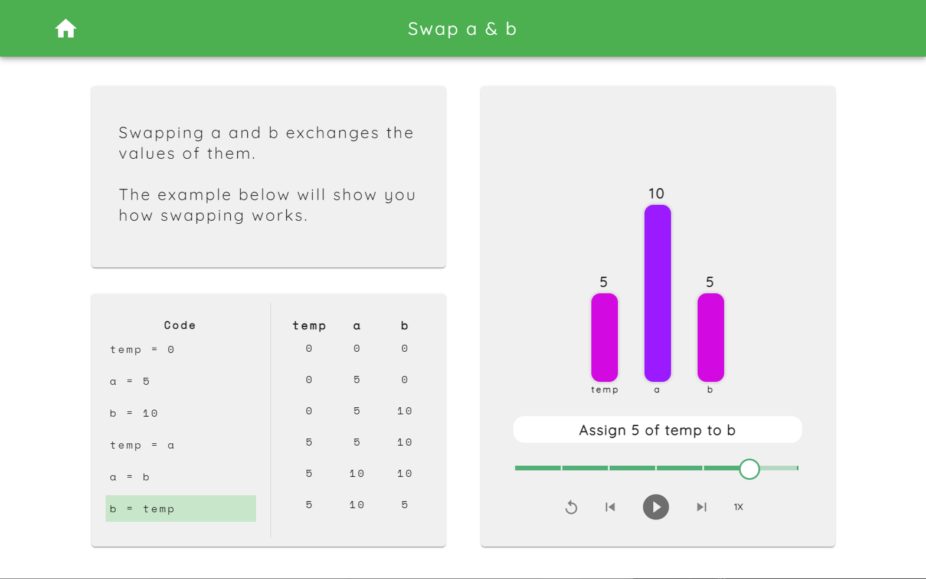

Figure 1. Swap a & b

There are three cards on this page, an introduction card, a code & variable table and a bar visualisation of the process. The top-left card contains an introduction to swapping and how to make use of this page. The code part at the bottom-left corner highlights the current executing step with a background of green. The vertical displayed table will update the real-time variable values step by step. By pressing the play button, it will demonstrate each step of swapping two variables automatically.